**BEEFLIX DOCUMENTATION**

This web application is used as the mid-term exam of the Web Programming Course. BeeFlix is a simple website that displays movies. The movies are divided into 3 categories Drama, Kids, and TV show. The website serves as an introductory project of the Laravel framework, as such the website is not complicated.

Full code: https://github.com/jason-aw/beeflix

**Home page**

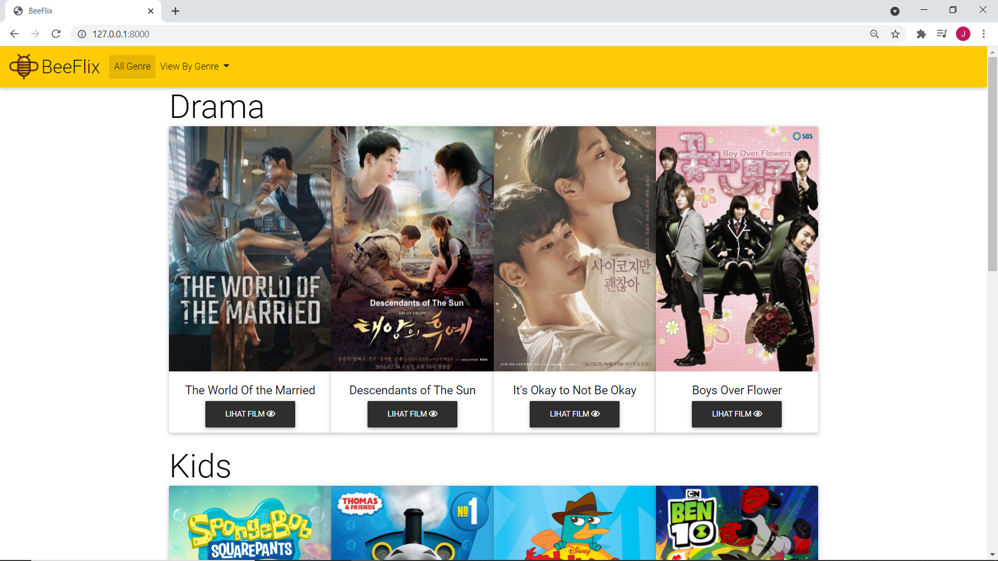

**View Movies by their categories**

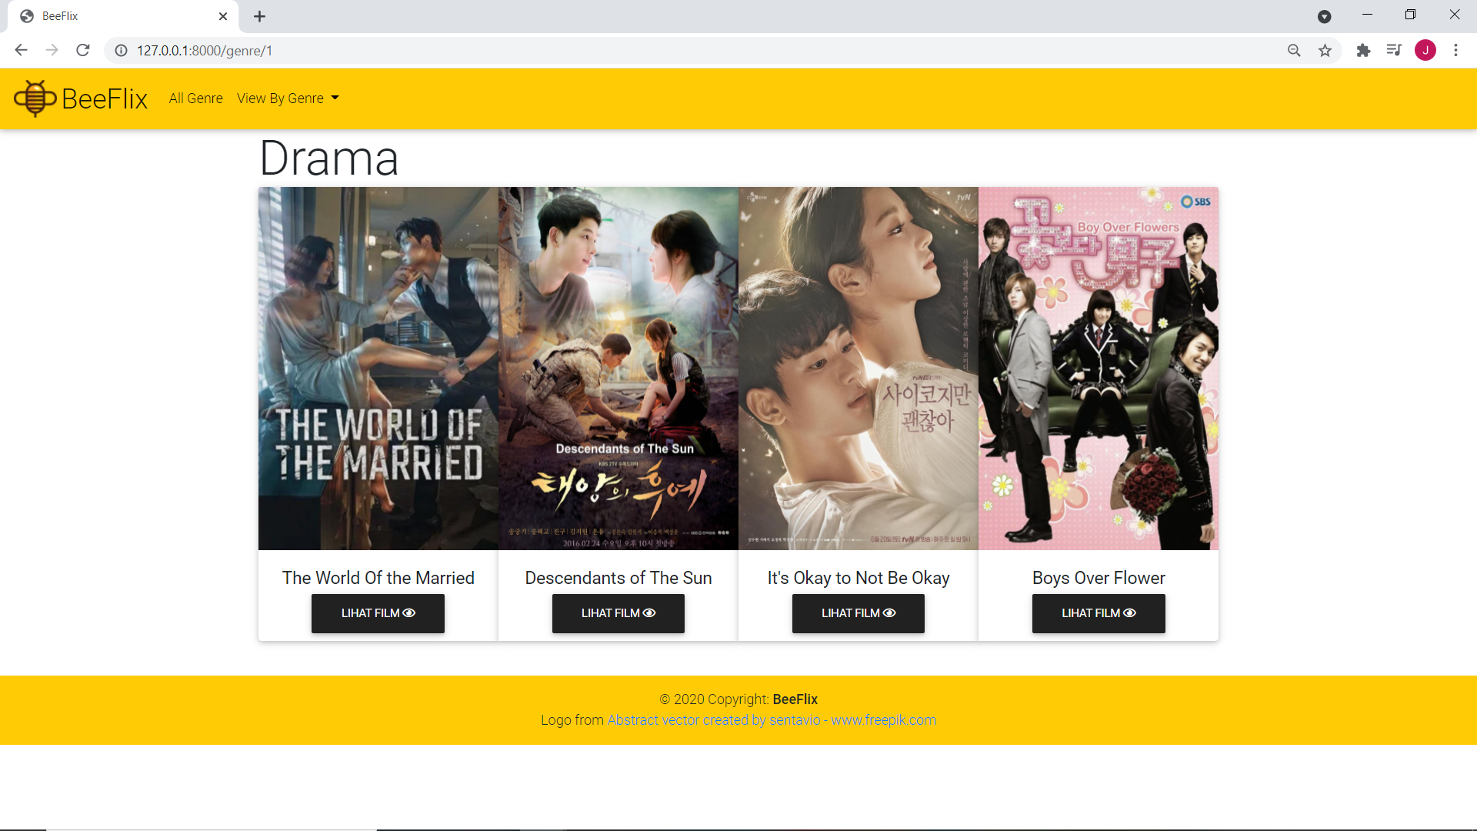

**Movie detail page**

